## APPENDIX 1

**TITLE OF PROJECT:**

**Contact/Address Book Scientfic Calculator**

**END TERM REPORT**

***by***

**Prashant Ranjan,Sahil Tiwari,Shantanu Kumar**

Section: K19PT

Roll-Numbers: 66,52,10



**Department of Intelligent Systems,**

**School of Computer Science Engineering,**

**Lovely Professional University, Jalandhar**

November, 2020

## APPENDIX 2

**Student Declaration**

This is to declare that this report has been written by me/us. No part of the report is copied from other sources. All information included from other sources have been duly acknowledged. I/We aver that if any part of the report is found to be copied, I/we are shall take full responsibility for it.

Signature: prashantranjan

Name:Prashant Ranjan

Roll Number:66

Date: 31/10/2020

**APPENDIX 3**

**TABLE OF CONTENTS**

**TITLE:Scientfic Calculator –using tkinter**

**5. Abstract**

**It is a scientific Calculator application.It is used to calculate the maths function easily.In the application two types of calculator are there**

**1.standard Calculator**

**2.scientfic Calculator**

**First one is very easy to solve arithmetic operations .And also convert the result into either integer or float pointing number.**

**And second one is scientific notation type maths function are there like sin,cos,tan,logetc. It is very useful to solve the odd math calculation in less time and in simple manner and also easily to use .**

**Especially I used menu bar with two items one is standard and second one is scientific after clicking the standard item it will shows the standard calculator after clicking the scientific item it will show the scientific calculator with standard also.**

**By using tkinter in python I developed this application it is also converted into .exe file by using pyinstaller then it is now a desktop application.**

**Lastly it shows desktop icon in our system if u install it otherwise not show in your desktop.**

**6. Python Tkinter GUI**

**Tkinter Programming**

Python offers various utilities to design the GUI wiz Graphical User Interface, and one such utility is Tkinter which is most commonly used. It is indeed one of the fastest and easiest ways to build GUI application. Moreover, Tkinter is cross-platform, hence the same code works on macOS, Windows, and Linux.****

**7. Python Calculator Project**

The python calculator which we are going to build will look something like this:

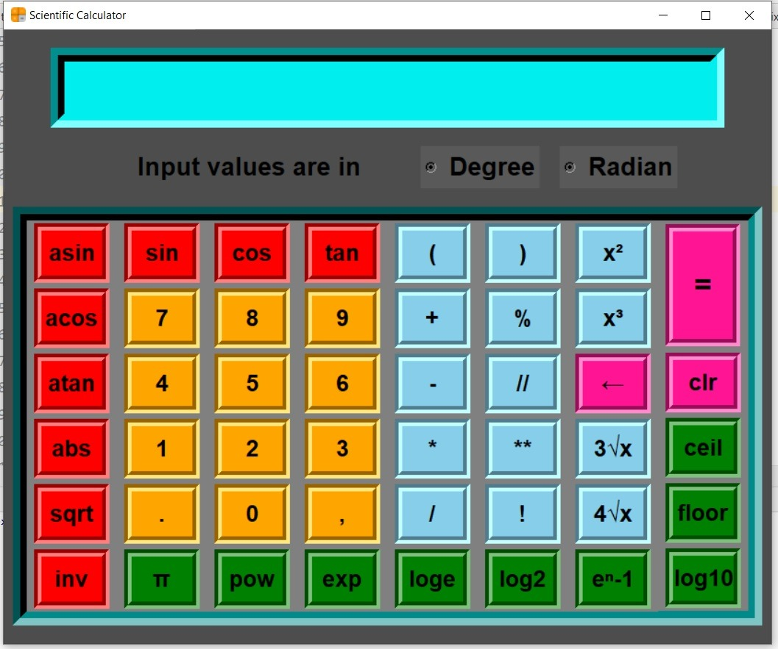

**GUI- Main Display window with name of the scientific calculator**

**8.Conclusion**

**This project has really been faithful and informative .It has made us learn and understand the many trival concept of python language .As we have used python Tkinter as aGUI it provides various control ,such as a button ,labels , and text boxes a user friendly application .**

**The fast using internet confirms the good future and scope of the proposed project.**

**Finally it has taught us a valuable liflelong lesson about the improvements and working**

**And interacting in a group.**

**9. Description of Work Division in terms of Roles among Students:**

**The work is done equally by three of us. We three have designed the project. Prashant (I) have made some part of code, Sahil also have contributed and made some part of code. Shantanu have made Report ,me and Sahil also helped in it and made.**